APTA NH Centennial Celebration Contest!
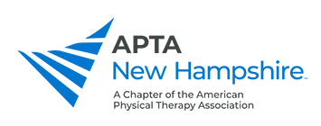
Let’s celebrate the 100th birthday of
Physical Therapy in New Hampshire!
APTA NH invites physical therapists, clinics, and institutions to participate in a competition to honor our profession.
This contest will coincide with the Physical Therapy Day of Service during the month of October 2021.
Submit photos or videos with article highlighting your Centennial 100 Contribution to nhapta@libertysquaregroup.com or videos can be loaded using this form
Contribution ideas for colleagues, schools, clinics/ larger institutions:
- Volunteer for 100 hours in your community (cumulative)
- Collect $100 to donate to local charity
- Collect 100 items to donate (example: food pantry, Salvation Army)
- Group donation of 100 pints of blood
- The sky is the limit!

Besides bragging rights, the winning submission will be awarded with a $100 Visa Gift Card
The contributions can be completed throughout the month of October (not just one day).
Submit by November 5, 2021

